**Tutorial – 1**

1.Program to Print an Integer (Entered by the User)

**Code:**

import java.util.Scanner;

class p1

{

  public static void main(String a[])

  {

    int x;

    Scanner sc=new Scanner(System.in);

    System.out.println("Enter the value of x:");

    x=sc.nextInt();

    System.out.println("Integer value is:"+x);

  }

}

**Output Screenshot:**

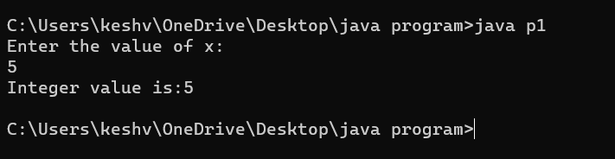

2.Write a Program to print the area of triangle.

**Code:**

import java.util.Scanner;

class p2

{

 public static void main(String i[])

 {

  Scanner sc=new Scanner(System.in);

  System.out.println("Enter h:");

  float h=sc.nextFloat();

  System.out.println("Enter b:");

  float b=sc.nextFloat();

  System.out.print("\narea="+(h*b/2));

  }

}

**Output Screenshot:**

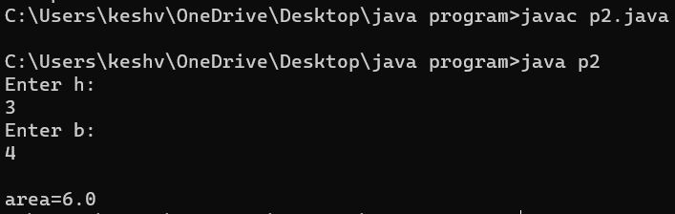

3.Program to Check Whether an Alphabet is Vowel or Consonant

**Code:**

public class alpha

{

 public static void main(String[] args)

 {

  char ch = 'i';

  if(ch == 'a' || ch == 'e' || ch == 'i' || ch == 'o' || ch == 'u' )

  {

  System.out.println(ch + " is vowel");

  }

  else

  {

  System.out.println(ch + " is consonant");

  }

 }

}

**Output Screenshot:**

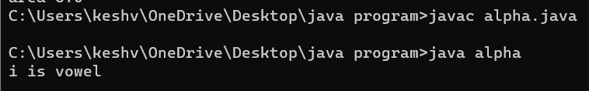

4.Program to Find ASCII Value of a character

**Code:**

import java.io.*;

class interest

{

    public static void main(String args[])

    {

        float P = 10000, R = 5, T = 5;

        float SI = (P * T * R) / 100;

        System.out.println("Simple interest = " + SI);

    }

}

**Output Screenshot:**

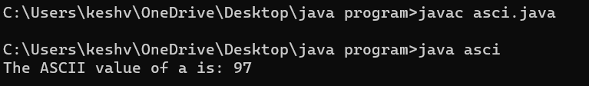

5. Java Program to Display Armstrong Number Between Two Intervals

**Code:**

class armstrong

{

   public static void main(String args[])

   {

      int num1, num2;

      Scanner sc = new Scanner(System.in);

      System.out.println("Enter the first number:");

      num1 = sc.nextInt();

      System.out.println("Enter the second number:");

      num2 = sc.nextInt();

      for (int i = num1; i<num2; i++)

    {

         int check, rem, sum = 0;

         check = i;

         while(check != 0)

       {

            rem = check % 10;

            sum = sum + (rem * rem * rem);

            check = check / 10;

         }

         if(sum == i)

       {

            System.out.println(""+i+" is an Armstrong number.");

         }

      }

   }

}

**Output Screenshot:**

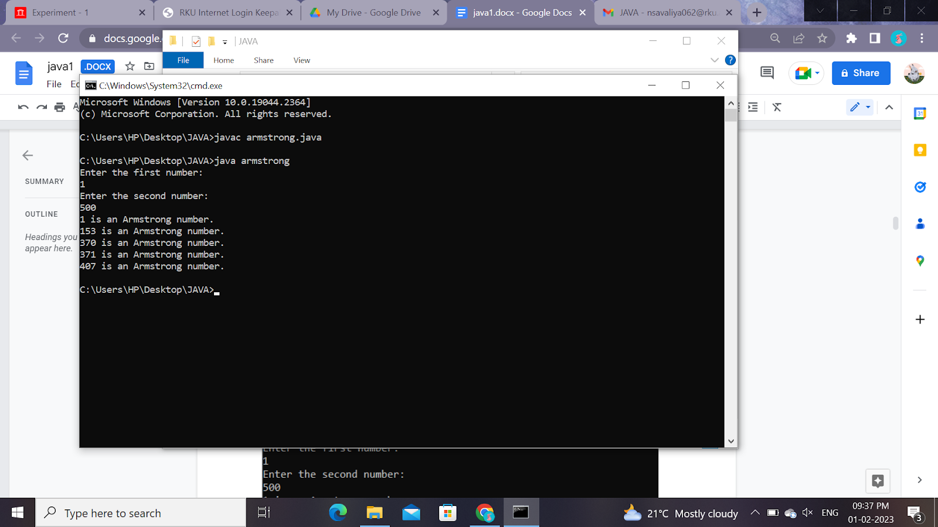

6.Java Program to Display Armstrong Number Between Two Intervals

**Code:**

//switch-case

import java.util.Scanner;

class calcu1

{

 public static void main(String args[])

 {

  Scanner sc=new Scanner(System.in);

  System.out.println("Enter value of a:");

  float a=sc.nextFloat();

  System.out.println("Enter value of b:");

  float b=sc.nextFloat();

  System.out.println("Enter your choice +,-,*,/:");

  char ch=sc.next().charAt(0);

  switch(ch)

   {

   case '+':System.out.println("Sum="+(a+b));

   break;

   case '-':System.out.println("Subtraction="+(a-b));

   break;

   case '*':System.out.println("Multiplication="+(a*b));

   break;

   case '/':System.out.println("Division="+(a/b));

   break;

   default:System.out.println("Enter invaild choice");

   }

 }

}

**Output Screenshot:**

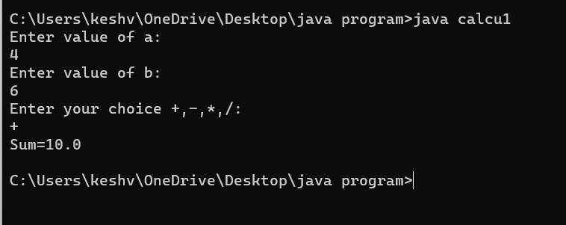

7.Write a java Program to check the number is Prime or not.

**Code:**

class prime {

    public static void main(String[] args) {

        int num = 29;

        boolean flag = false;

        for (int i = 2; i <= num / 2; ++i) {

            if (num % i == 0) {

            flag = true;

            break;

            }

        }

        if (!flag)

        System.out.println(num + " is a prime number.");

        else

        System.out.println(num + " is not a prime number.");

    }

}

**Output Screenshot:**

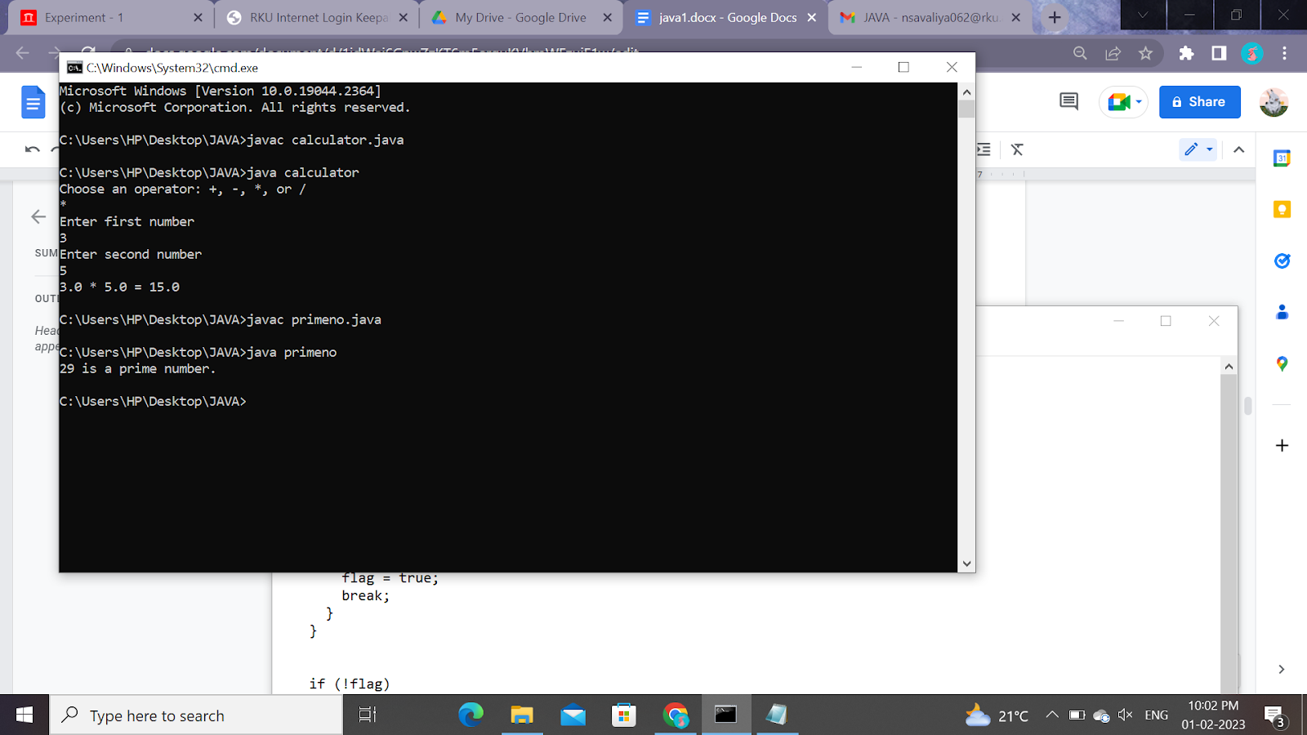

8.Java Program to Calculate Average Using Arrays

**Code:**

class arrays {

    public static void main(String[] args) {

        double[] numArray = { 65.3, 97.5, -85.6, 26.34, 84.0, 63.6 };

        double sum = 0.0;

        for (double num: numArray) {

            sum += num;

        }

        double average = sum / numArray.length;

        System.out.format("The average is: %.2f", average);

    }

}

**Output Screenshot:**

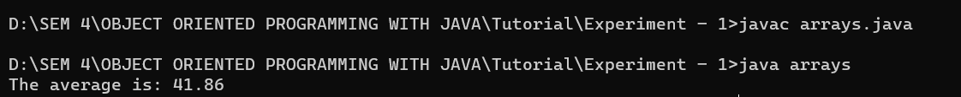

9.java Program to Find Largest Element of an Array.

**Code:**

class largarray {

    public static void main(String[] args) {

        int [] arr = new int [] {65, 53, 46, 86, 16};

        int max = arr[0];

        for (int i = 0; i < arr.length; i++) {

            if(arr[i] > max)

            max = arr[i];

        }

        System.out.println("Largest element present in given array: " + max);

    }

}

**Output Screenshot:**

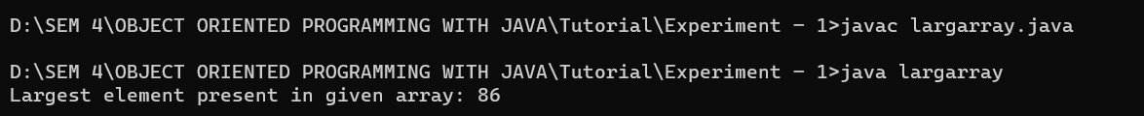

10.Java Program to Add Two Matrix Using Multi-dimensional Arrays

**Code:**

class addmatrices {

    public static void main(String[] args) {

        int rows = 2, columns = 3;

        int[][] firstMatrix = { {4, 2, 3}, {5, 2, 3} };

        int[][] secondMatrix = { {-4, 3, 4}, {4, 6, 6} };

        int[][] sum = new int[rows][columns];

        for(int i = 0; i < rows; i++) {

            for (int j = 0; j < columns; j++) {

                sum[i][j] = firstMatrix[i][j] + secondMatrix[i][j];

            }

        }

        System.out.println("Sum of two matrices is: ");

        for(int[] row : sum) {

            for (int column : row) {

                System.out.print(column + "    ");

            }

            System.out.println();

        }

    }

}

**Output Screenshot:**

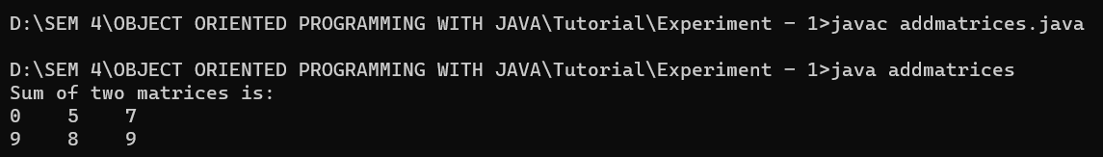

11.Java Program to Find the Sum of Natural Numbers using Recursion

**Code:**

public class sumnumbersR {

    public static void main(String[] args) {

        int number = 20;

        int sum = addNumbers(number);

        System.out.println("Sum = " + sum);

    }

    public static int addNumbers(int num) {

        if (num != 0)

            return num + addNumbers(num - 1);

        else

            return num;

    }

}

**Output Screenshot:**

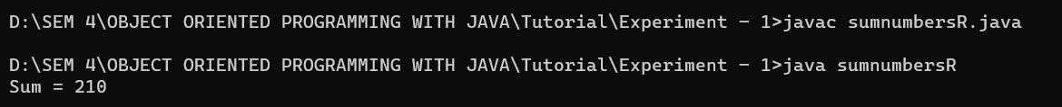

12.Java Program to Reverse a Sentence Using Recursion

**Code:**

class reverse {

  public static void main(String[] args) {

  String sentence = "VIRAJ CHHAYANI";

  String reversed = reverse(sentence);

  System.out.println("The reversed sentence is: " + reversed);

  }

  public static String reverse(String sentence) {

    if (sentence.isEmpty())

    return sentence;

    return reverse(sentence.substring(1)) + sentence.charAt(0);

  }

}

**Output Screenshot:**

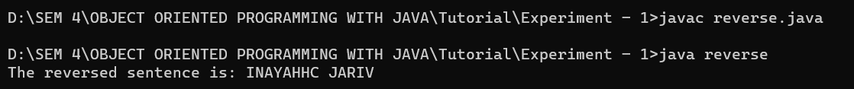

13.Write a java program to find the Fibonacci series using recursive and non recursive functions.

**Code:**

class nonreverse {

    public static void main(String args[]) {

        int n1 = 0, n2 = 1, n3, i, count = 10;

        System.out.print(n1 + " " + n2);

        for (i = 2; i < count; ++i) {

            n3 = n1 + n2;

            System.out.print(" " + n3);

            n1 = n2;

            n2 = n3;

        }

    }

}

**Output:**

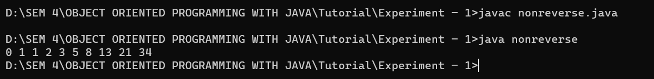

14.Java Program to Calculate Difference Between Two Time Periods

**Code:**

class Time {

    int seconds;

    int minutes;

    int hours;

    public Time(int hours, int minutes, int seconds) {

*this*.hours = hours;

*this*.minutes = minutes;

*this*.seconds = seconds;

    }

    public static void main(String args[]) {

        Time start = new Time(8, 12, 15);

        Time stop = new Time(12, 34, 55);

        Time diff;

        diff = difference(start, stop);

        System.out.printf("TIME DIFFERENCE: %d:%d:%d - ", start.hours, start.minutes, start.seconds);

        System.out.printf("%d:%d:%d ", stop.hours, stop.minutes, stop.seconds);

        System.out.printf("= %d:%d:%d\n", diff.hours, diff.minutes, diff.seconds);

    }

    public static Time difference(Time start, Time stop) {

        Time diff = new Time(0, 0, 0);

        if (start.seconds > stop.seconds) {

            --stop.minutes;

            stop.seconds += 60;

        }

        diff.seconds = stop.seconds - start.seconds;

        if (start.minutes > stop.minutes) {

            --stop.hours;

            stop.minutes += 60;

        }

        diff.minutes = stop.minutes - start.minutes;

        diff.hours = stop.hours - start.hours;

        return (diff);

    }

}

**Output:**

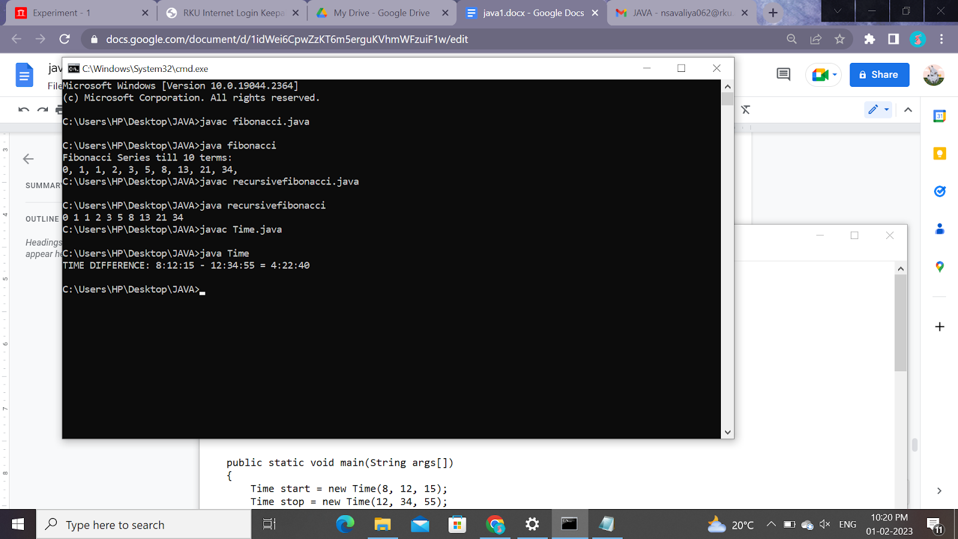

15.Java Program to Calculate Difference Between Two Time Periods

**Code:**

class arrayvalue {

    public static void main(String args[]) {

        int num[] = { 1, 2, 3, 4, 5 };

        int toFind = 3;

        boolean found = false;

        for (int n : num) {

            if (n == toFind) {

                found = true;

                break;

            }

        }

        if (found)

            System.out.println(toFind + " is found.");

        else

            System.out.println(toFind + " is not found.");

    }

}

**Output:**

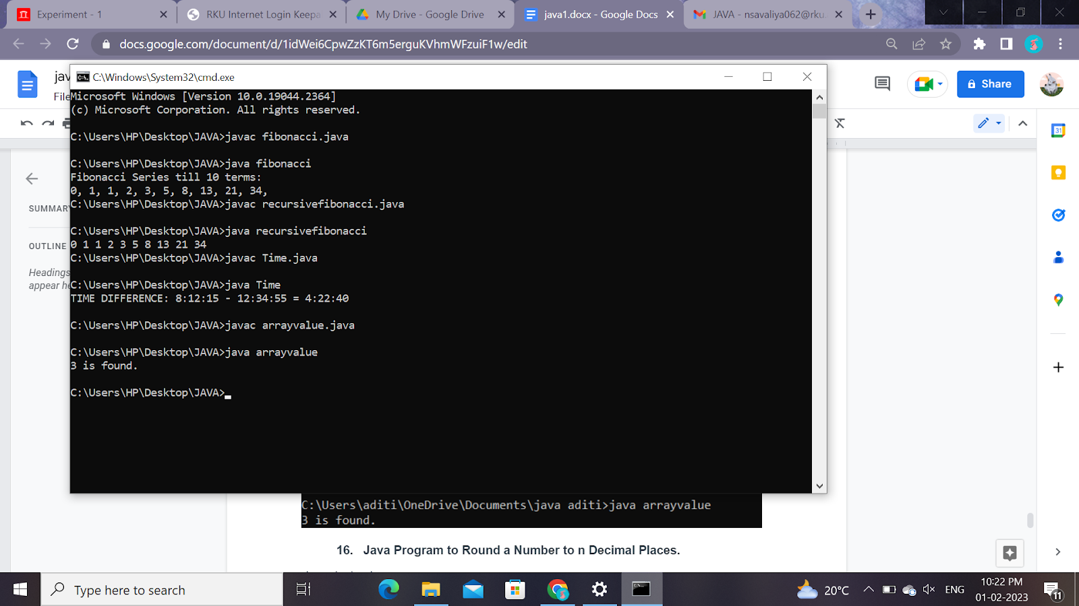

16.Java Program to Calculate Difference Between Two Time Periods

**Code:**

class decimal {

    public static void main(String[] args) {

        double num = 1.34567;

        System.out.format("%.4f", num);

    }

}

**Output:**

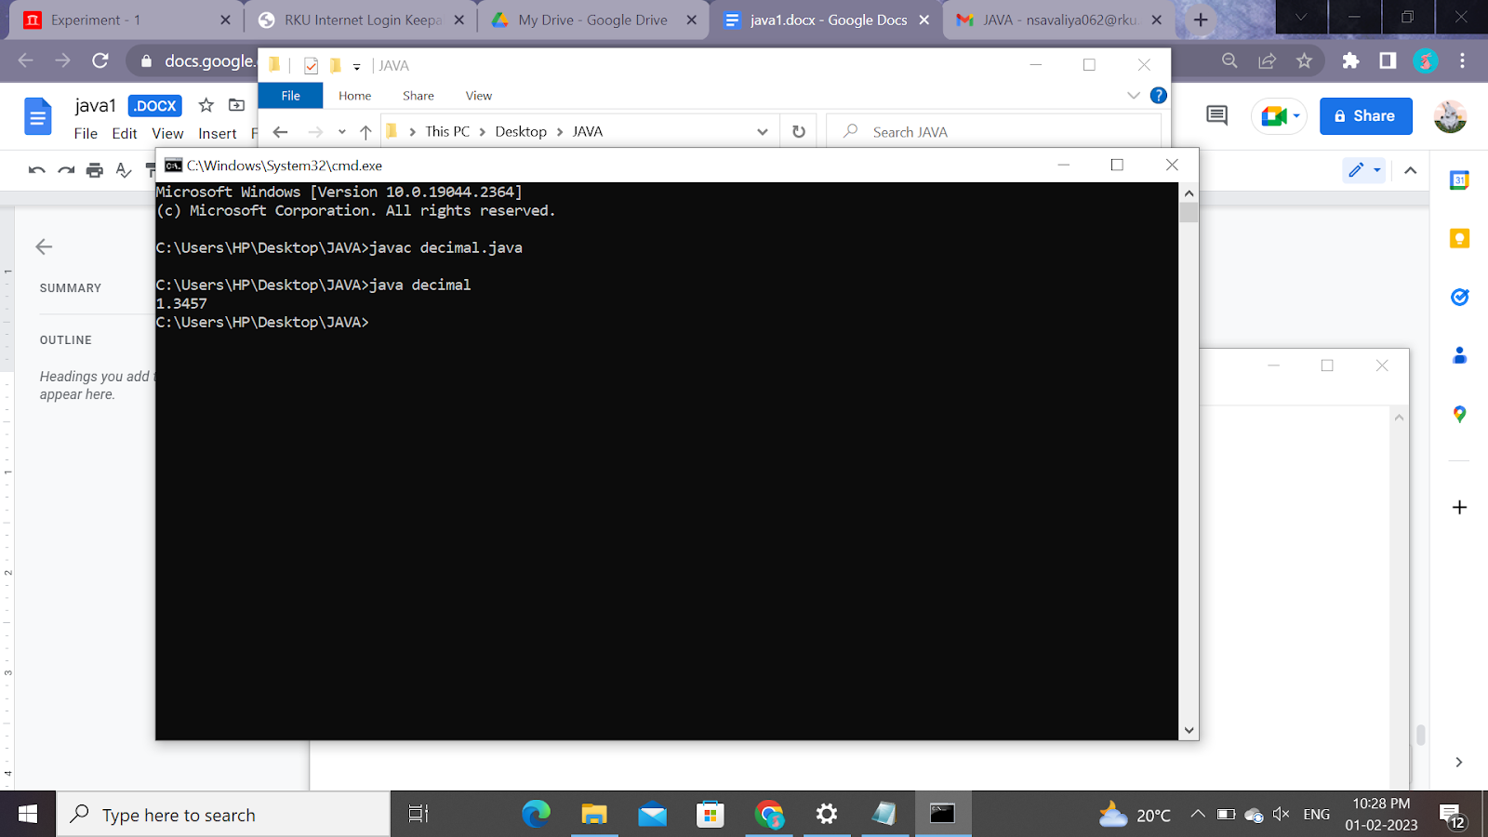

17.Java Program to Calculate Difference Between Two Time Periods

**Code:**

class charconvert {

    public static void main(String args[]) {

        char ch = '3';

        System.out.println("char value: " + ch);

        int a = ch - '0';

        System.out.println("int value: " + a);

    }

}

**Output:**

